Deployment Process Document

**Contents**

1. Pages Creation and Import the Widgets (Widget Deployment)

2. Creation of Master Page

3. Import the Portal and Export the Portal

**Import the widgets (Widget Deployment)**

**Step-1:** Go to CXP Manager and enter user id and password then click on Log in button.

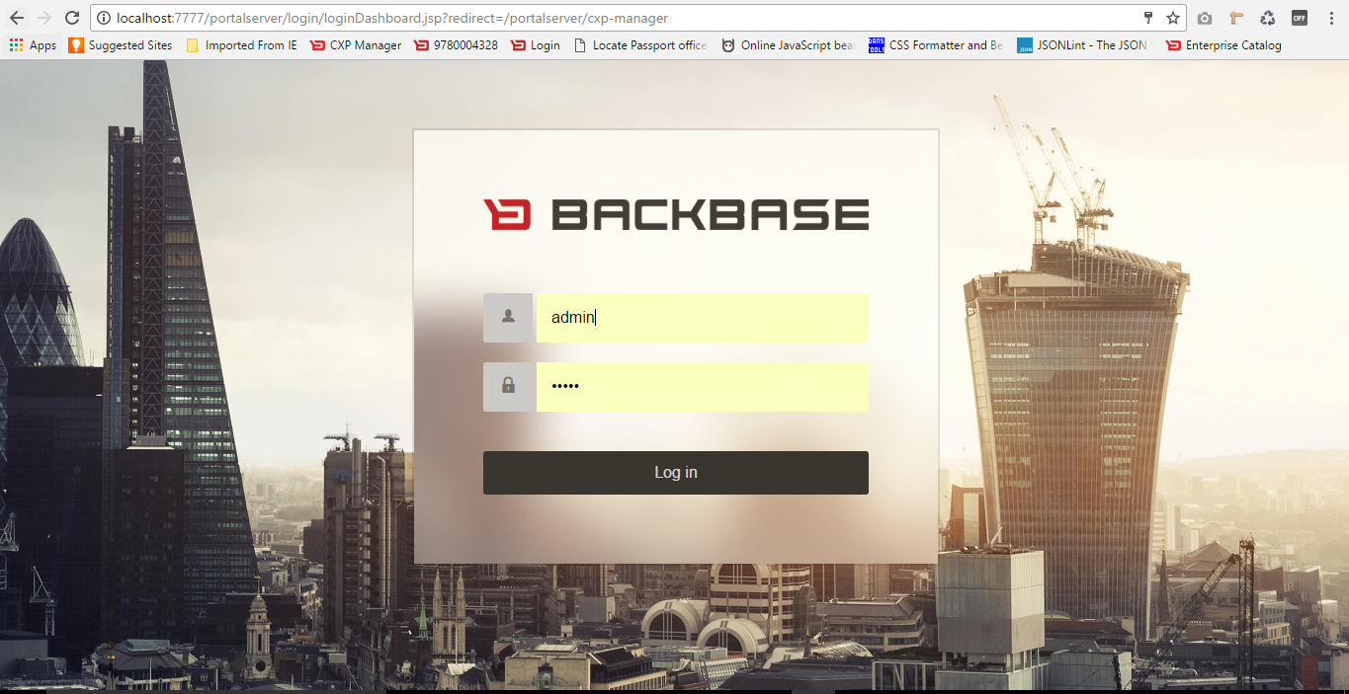

**Step-2:** Click on Enterprise Catalog in left menu.

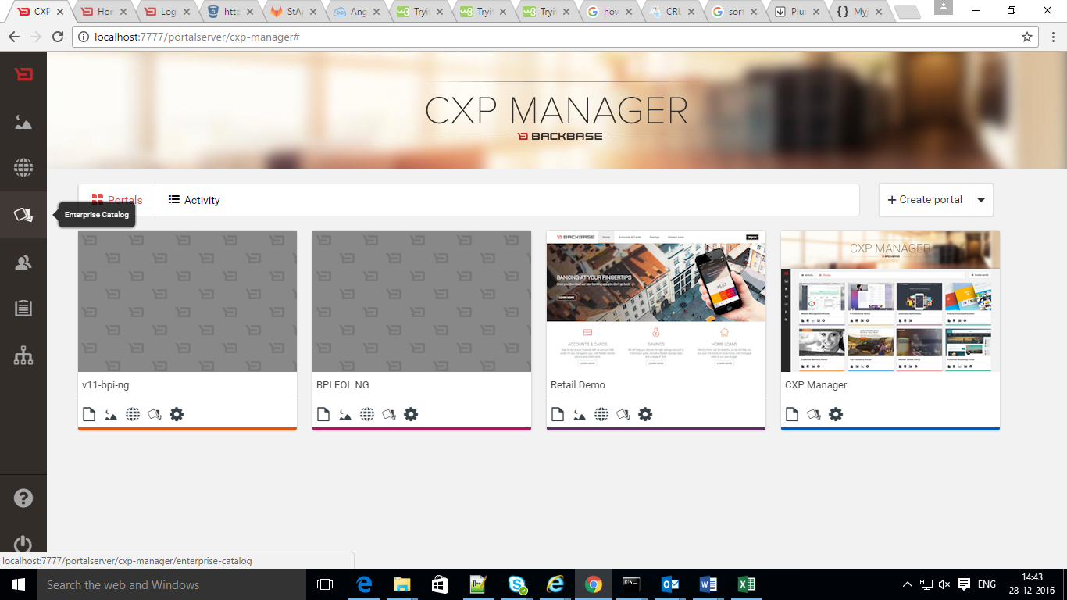

**Step-2:** Click Import Button and drag and drop the required widget.

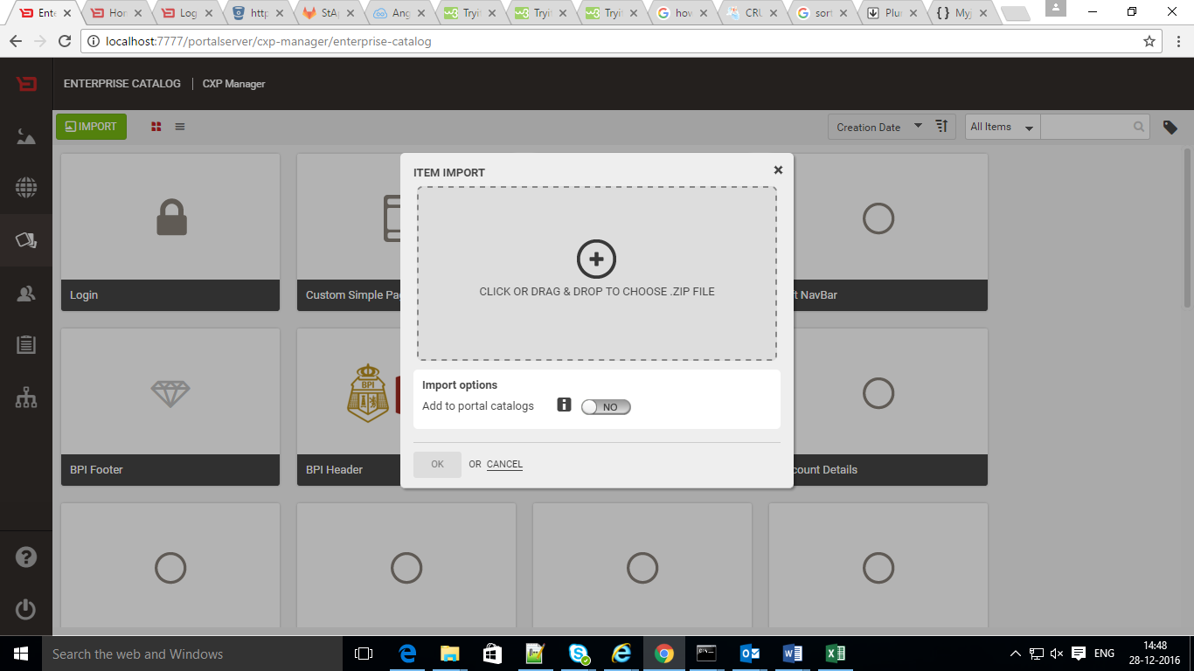

**Step-3:** After Drag & Drop widget enable the Add to portal catalogs and click on ok button.

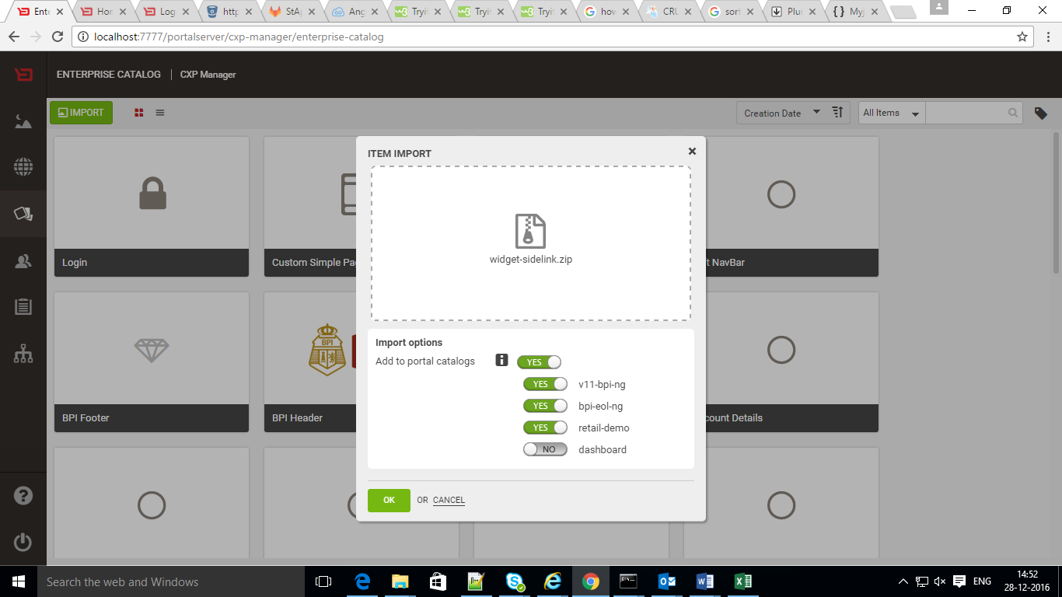

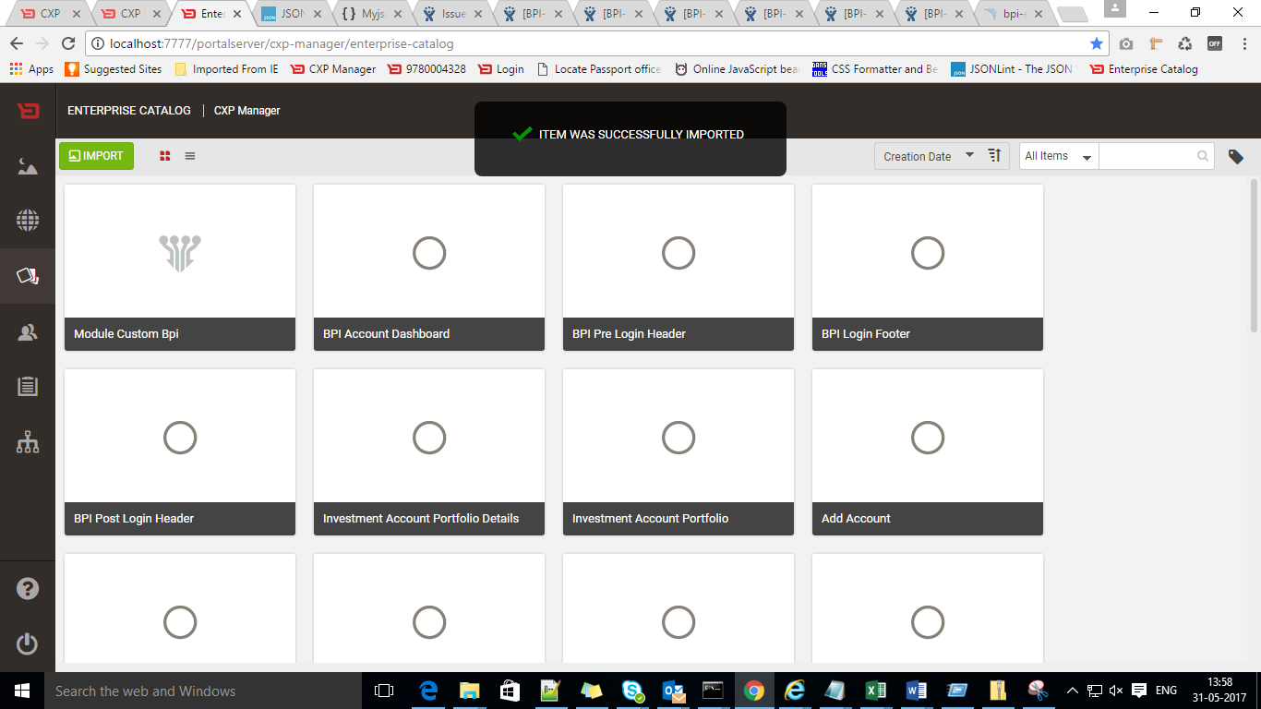

**Steps For Import the Portal**

**Step-1:** Go to CXP manager and Click on the Import portal

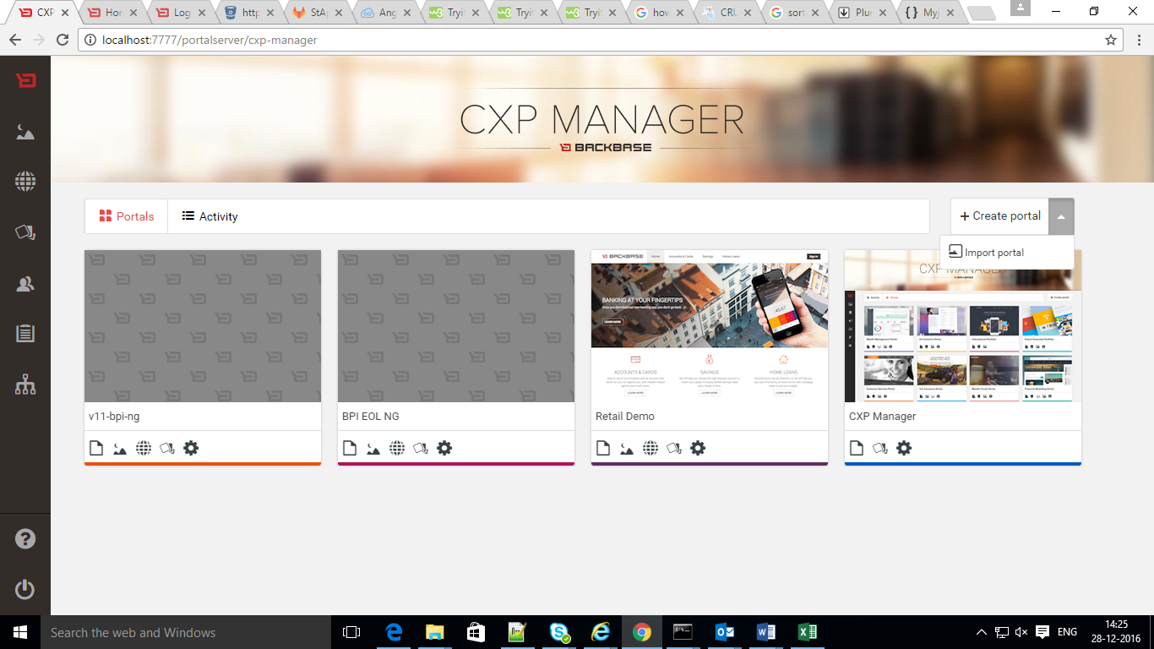

**Step-2:** Click or Drag & Drop Downloaded portal and Click on import button.

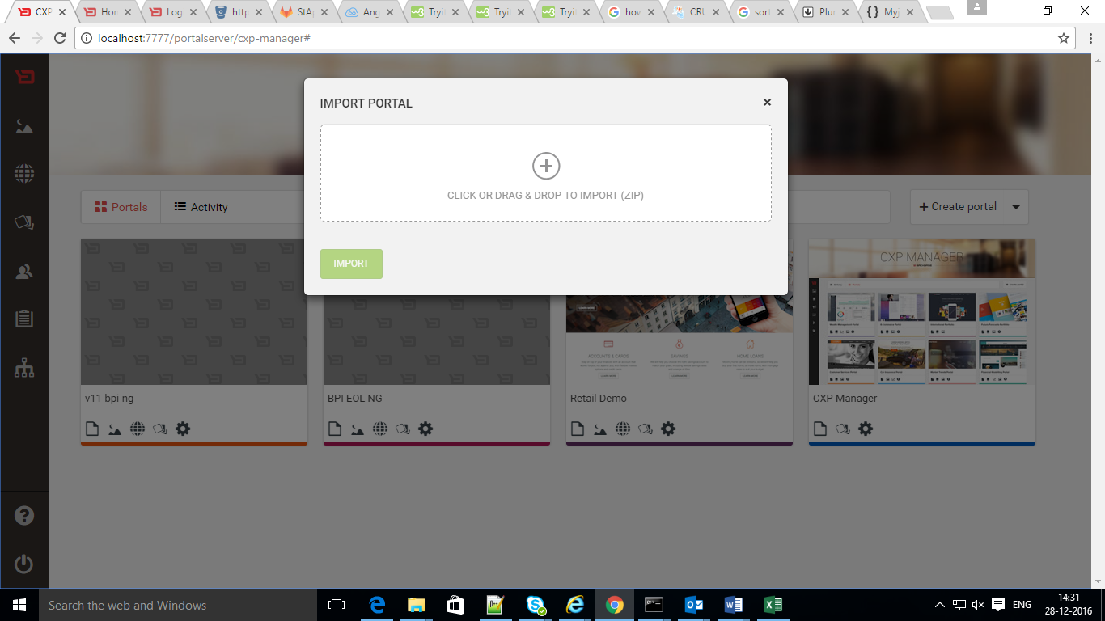

Issues and Troubleshooting

1. If you get any server error at the time of importin a portal, that time you need to restart the server.
2. Getting Error message like ‘missing widget-xyz’ , it means you need to import that missing widget also.

**Creation Of Master page**

**Step-1:** Click “+” Symbol in the MASTER PAGES tab.

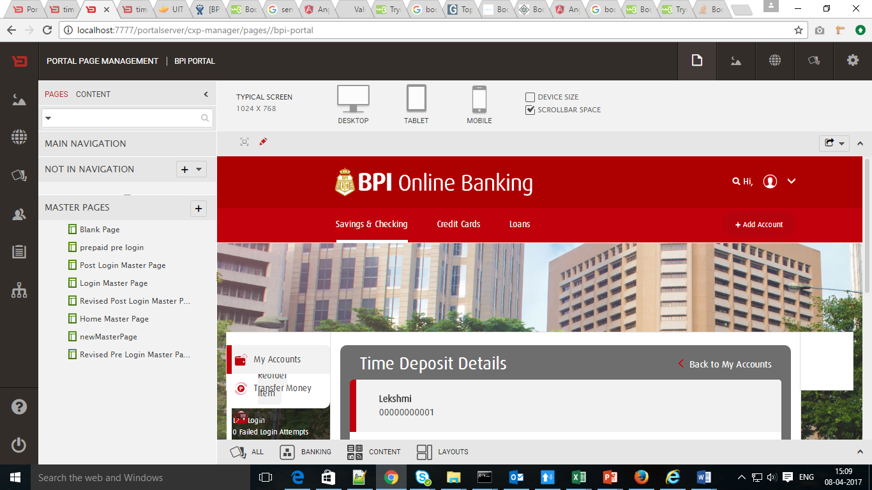

**Step-2**: Give the page title and select Page Template as “Launchpad Page Template” and Click “Save” button.

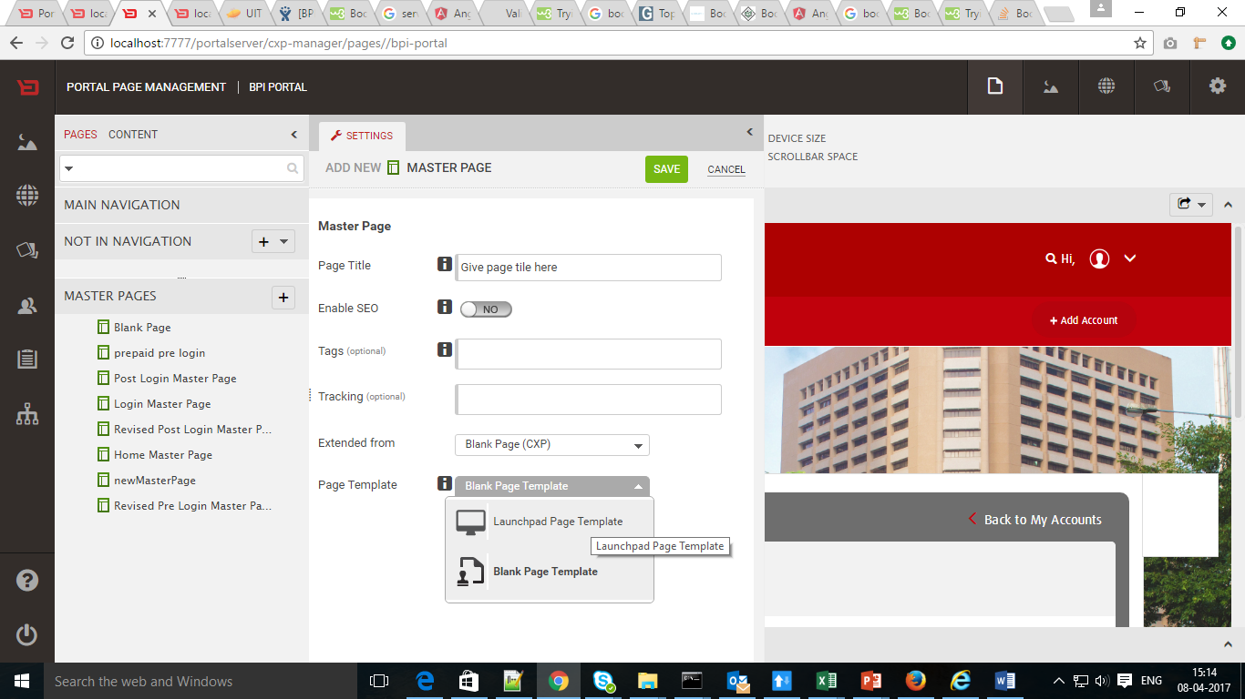

**Step-3**: Created master Page will be displayed in Master Pages Tab. On clicking on that page You will see EDIT button.

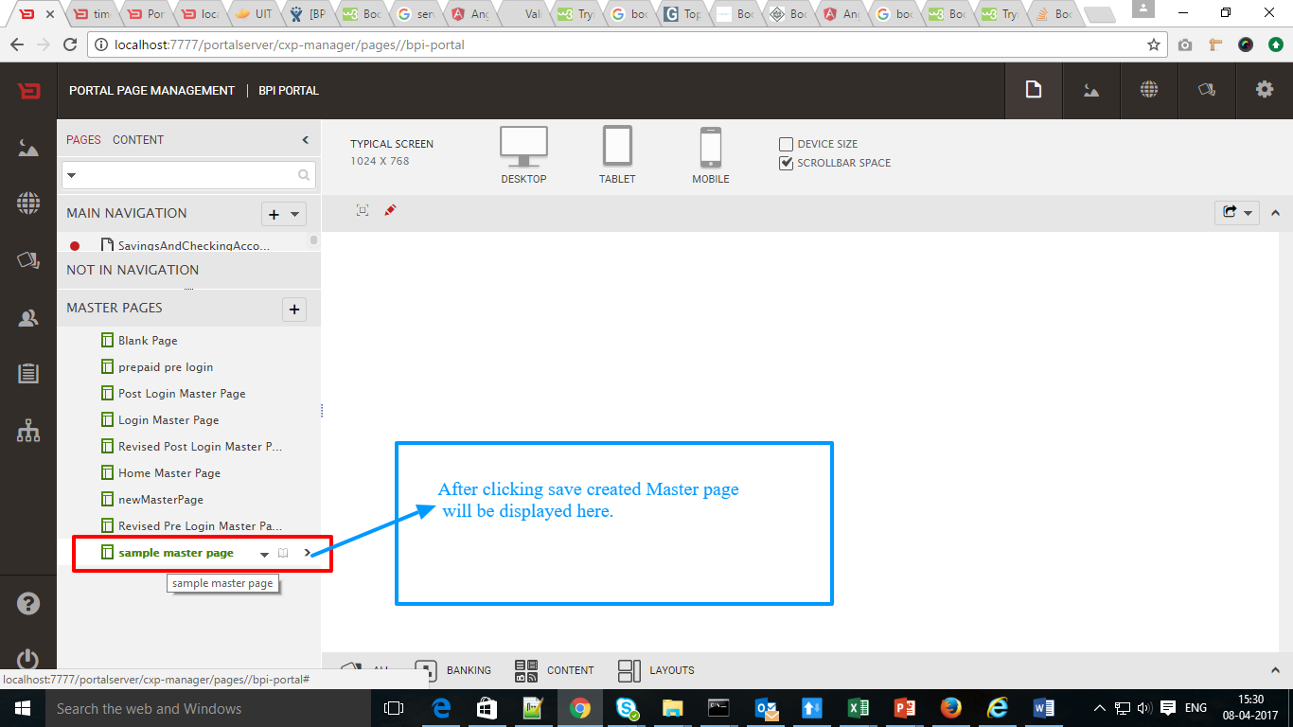

**Step-4**: Click on the EDIT button to change Master Page Settings

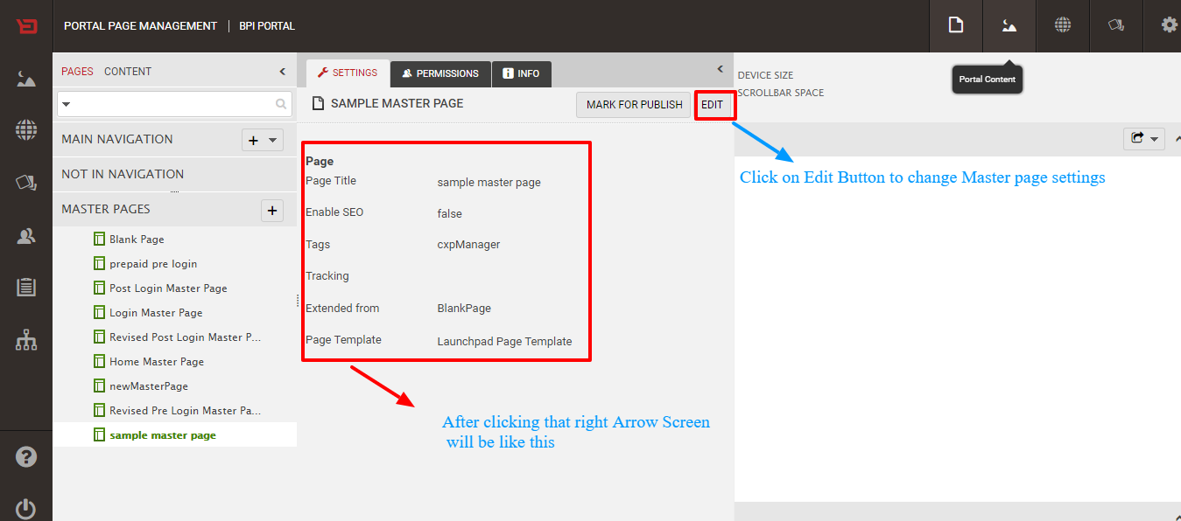

**Step-5**: After Click On EDIT do the changes and save

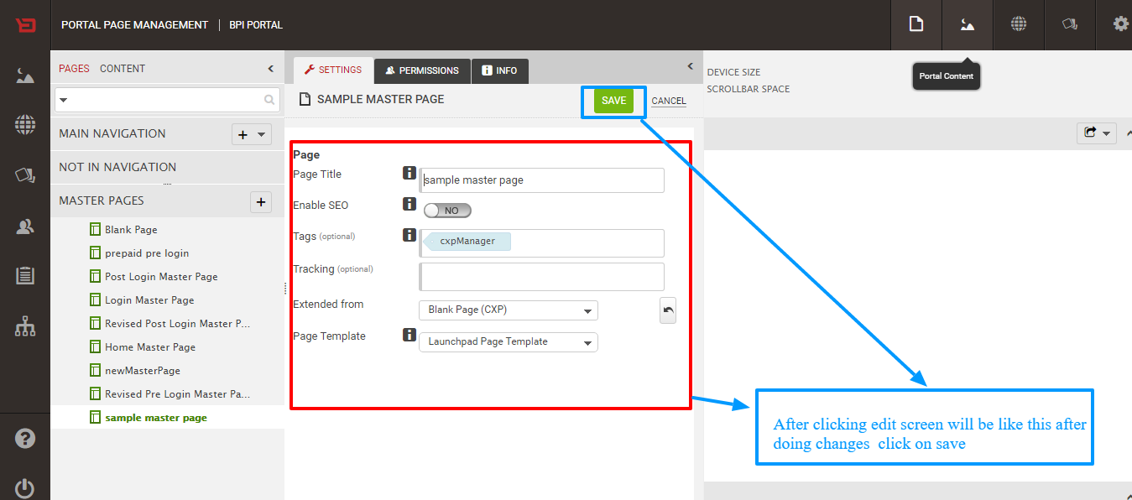

**Step-6**: To close the Page click on Arrow

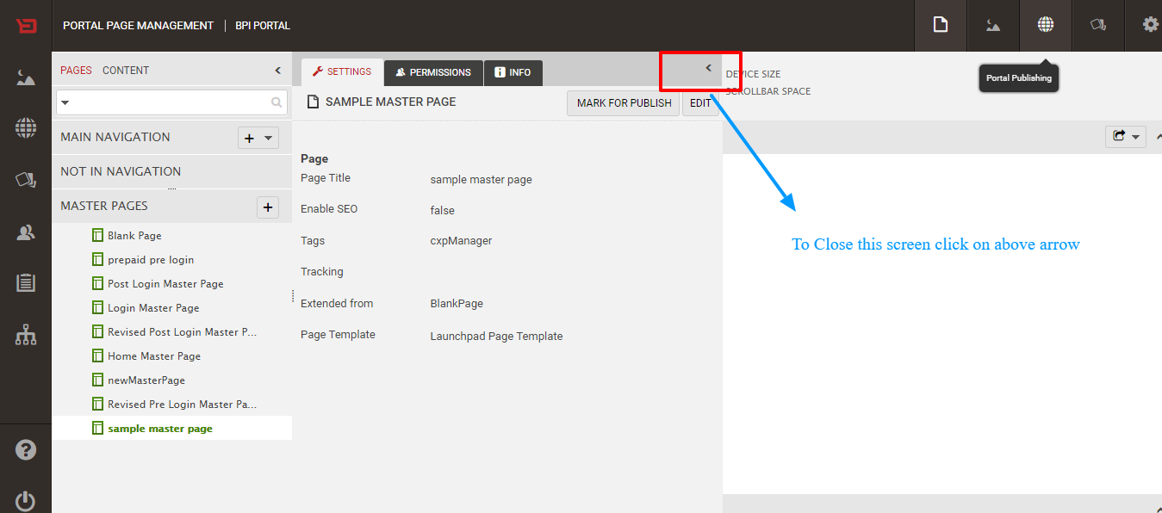

**Step-7**: To select the widgets click on down arrow which is showing in the figure

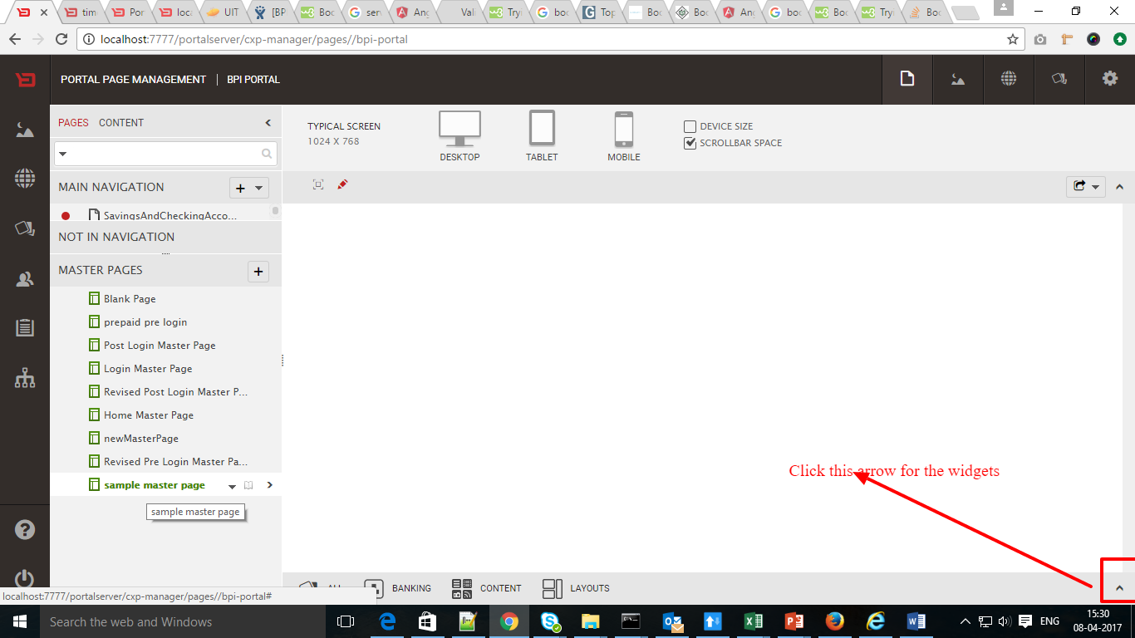

**Step-8**: Search the required widget in the search tab

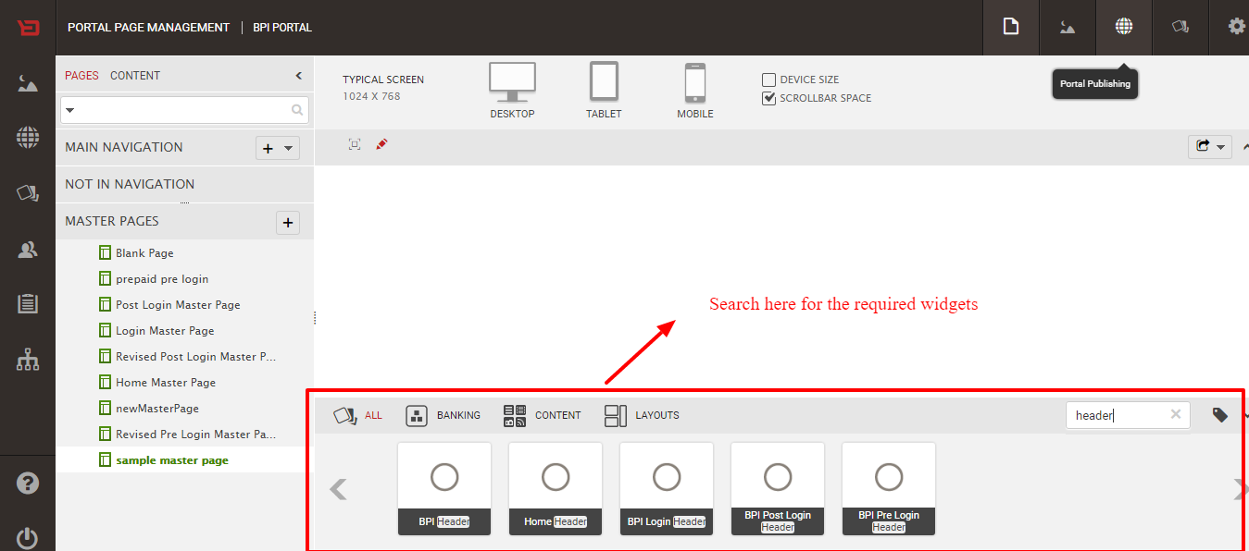

**Step-9**: Drag the selected widget into the top of the master page

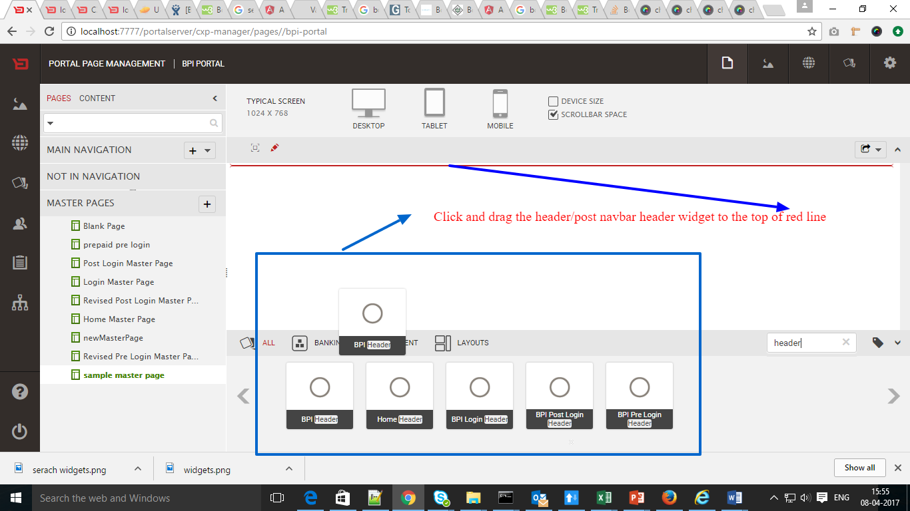

**Step-10**: Search the Simple Page layout and drag that widget under the header in the Master Page

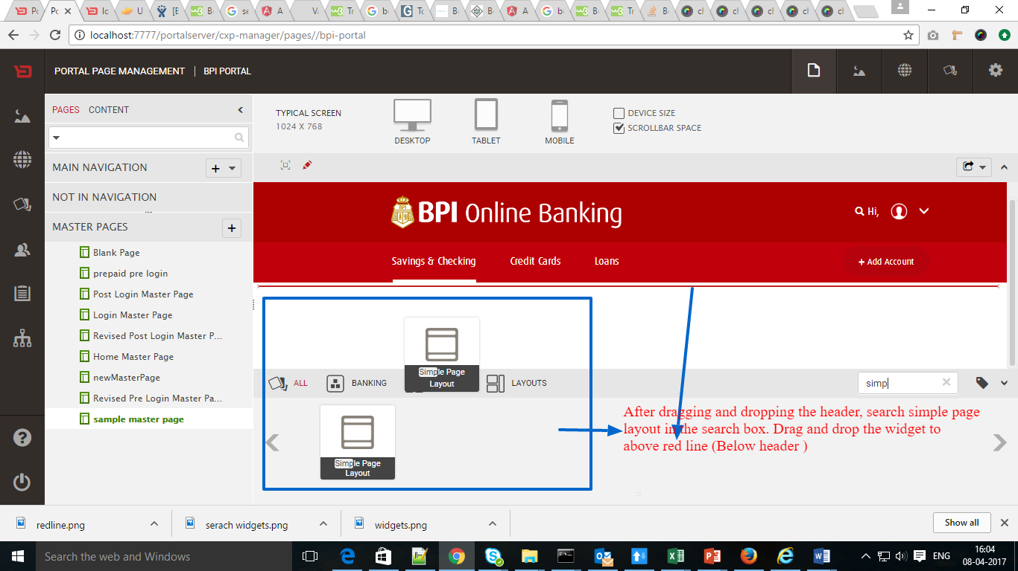

**Step-11**: Drag and drop the column widget inside of Simple Page Layout to divide the side links and Middle Part

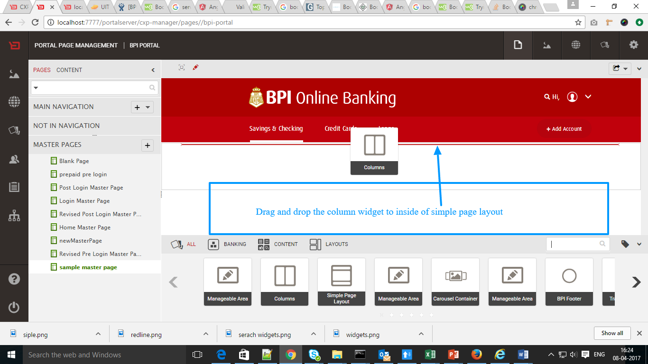

**Step-12**: After Drag the specified widgets the screen looks like below

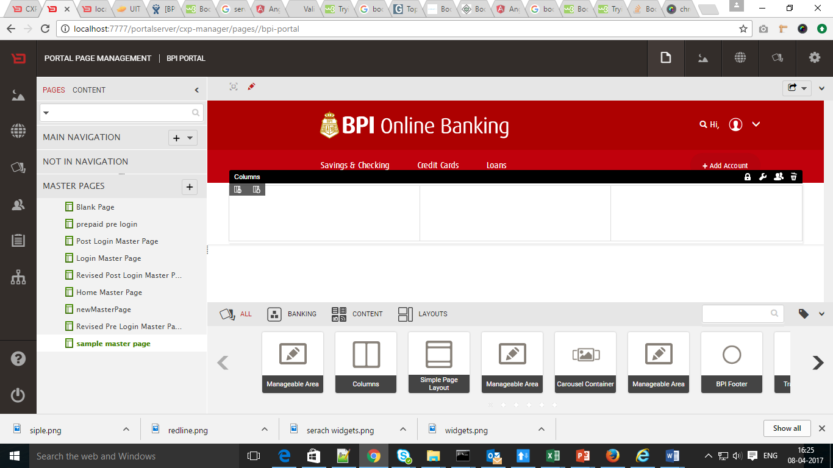

**Step-13**: To change Settings click on Settings button as shown in the figure and save the changes

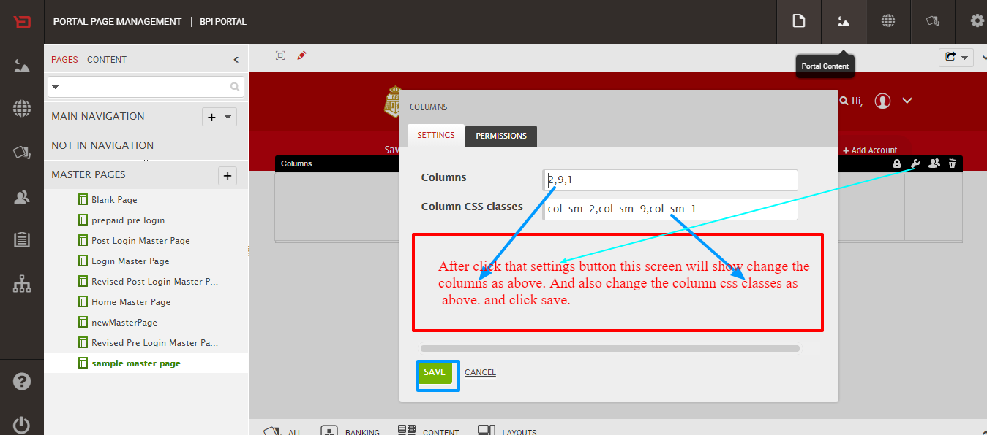

**Step-14**: The page should be two columns drag and drop the manageable area widget to centre part and side links to the left part

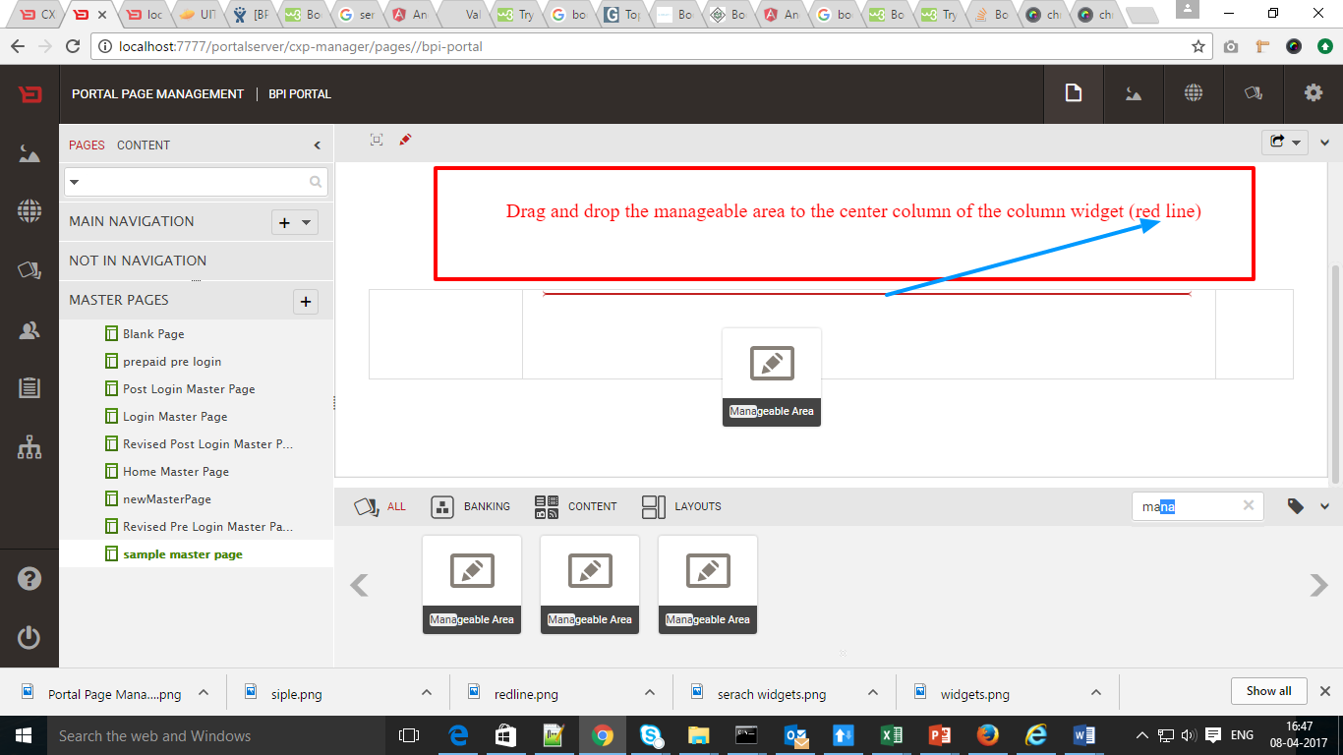

**Step-15**: Drag and drop the advanced content widget after the Simple Page Layout

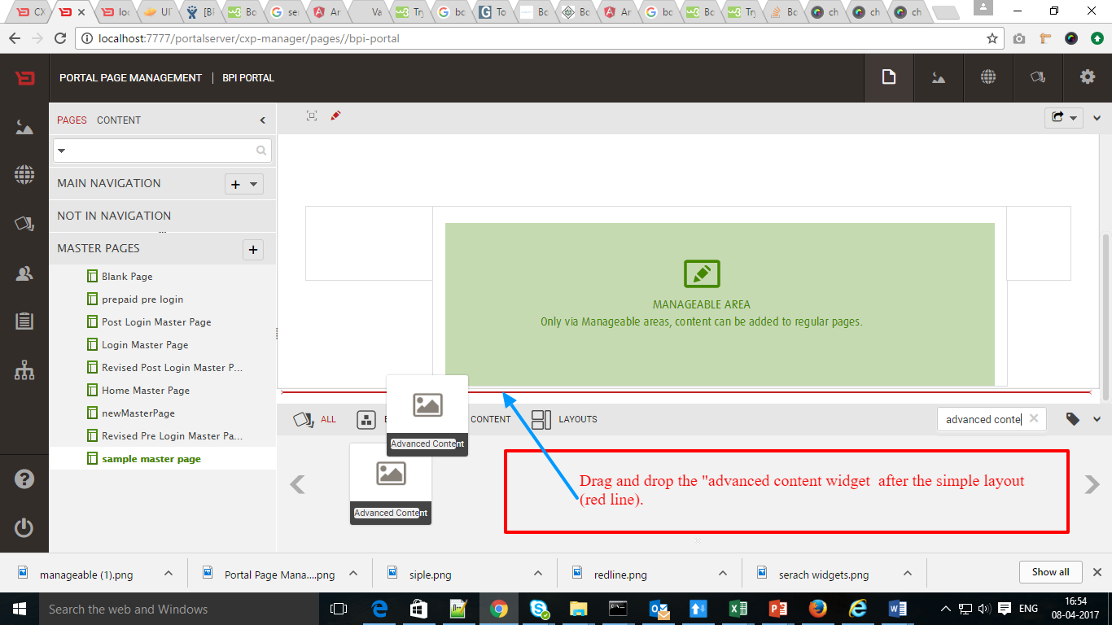

**Step-16**: The page should look like below after dropping the advanced content widget

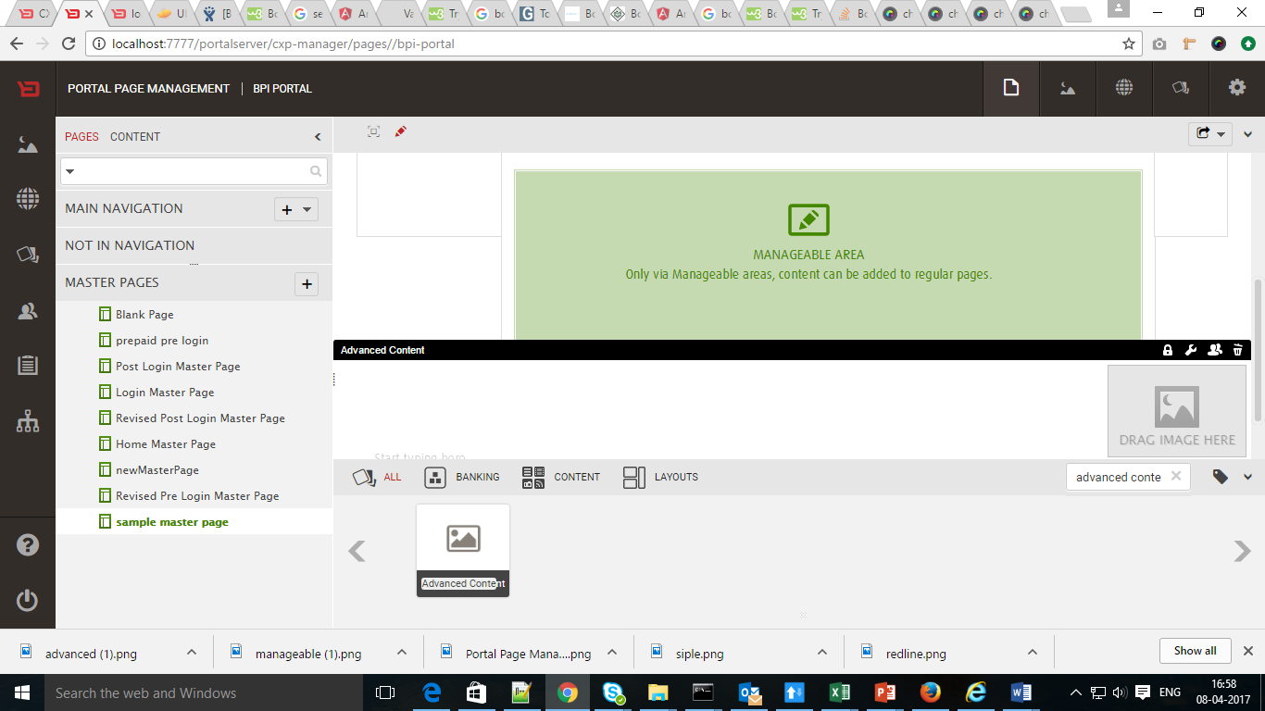

**Step-16**: To select the image click on CONTENT after click on SHARED CONTENT

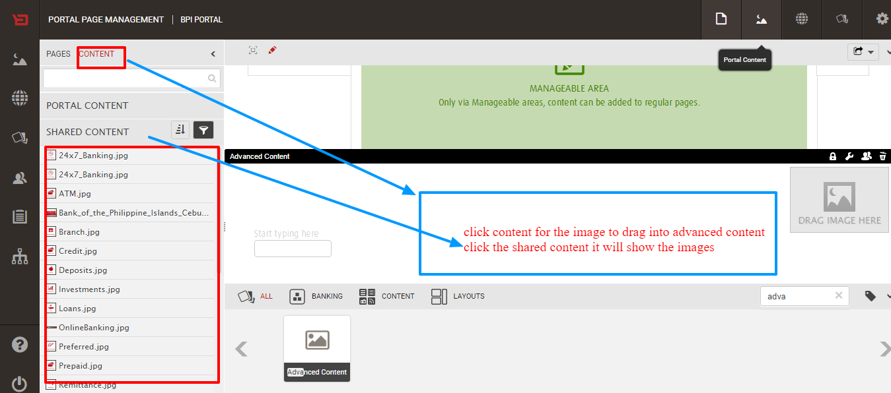

**Step-17**: Drag and drop the Selected image

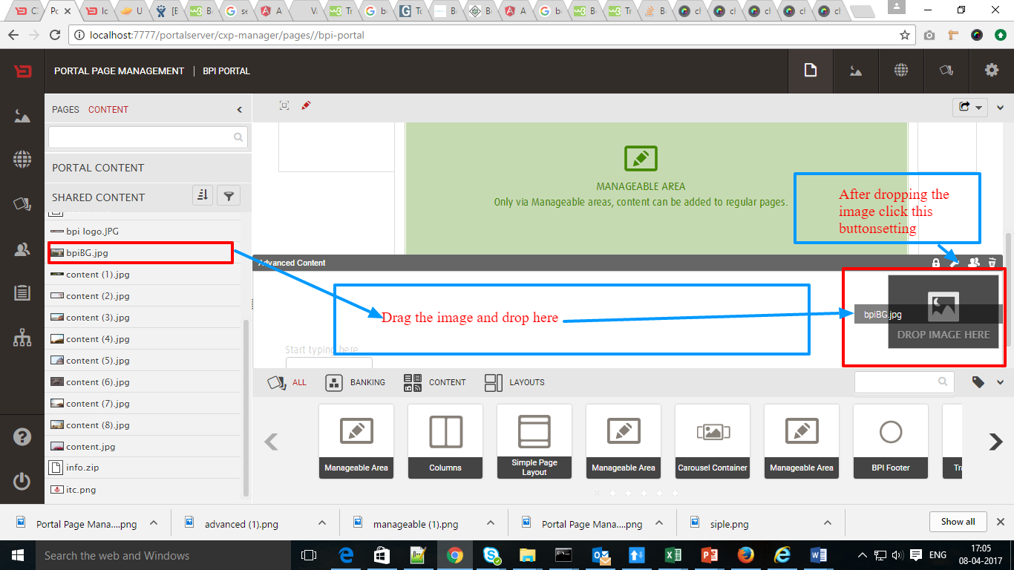

**Step-18**: To change Image settings click on that image and select scroll in In Background Scroll

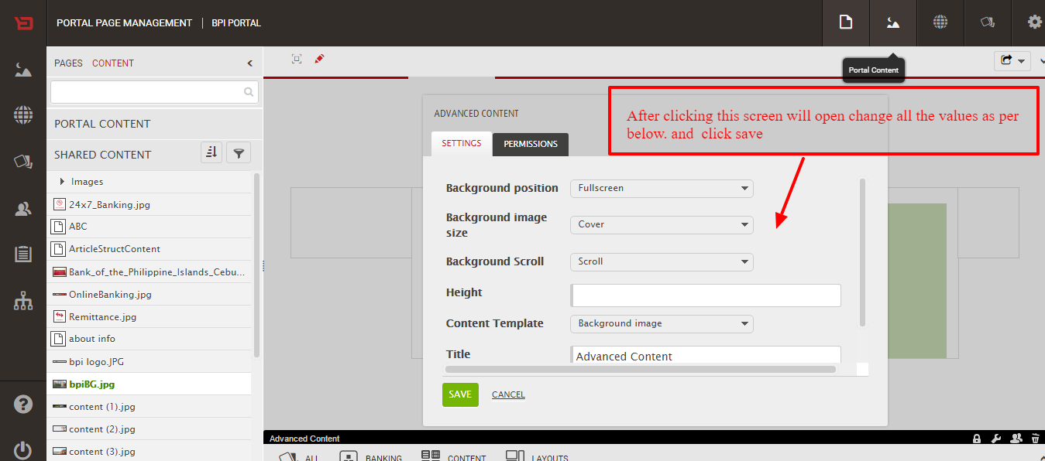

**Step-19**: Now the Master Page looks like below

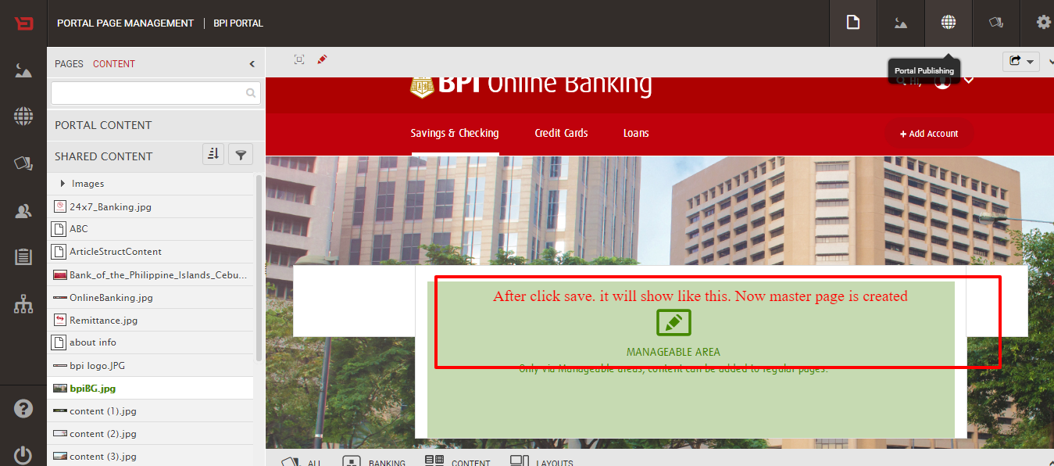

**Creation Of Pages**

**Step-1**: Click on “+” Symbol in NOT IN NAVIGATION tab to create a page and give page name in Menu tittle and select the respective master page from master page menu and click on Save button

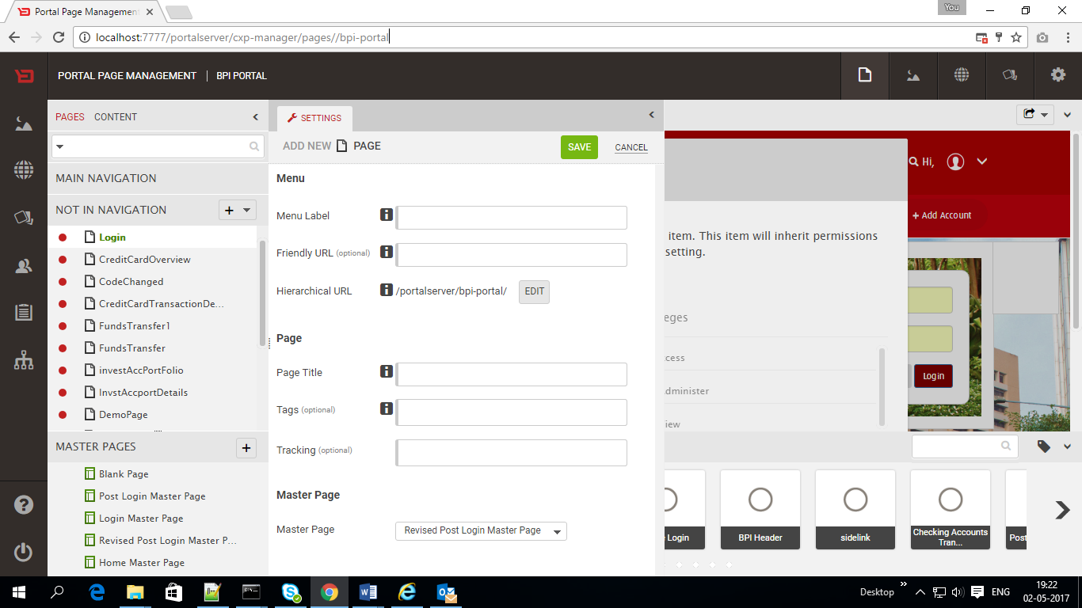

**Step-2**: The page will look like below drag and drop the required widget in the middle part of the page

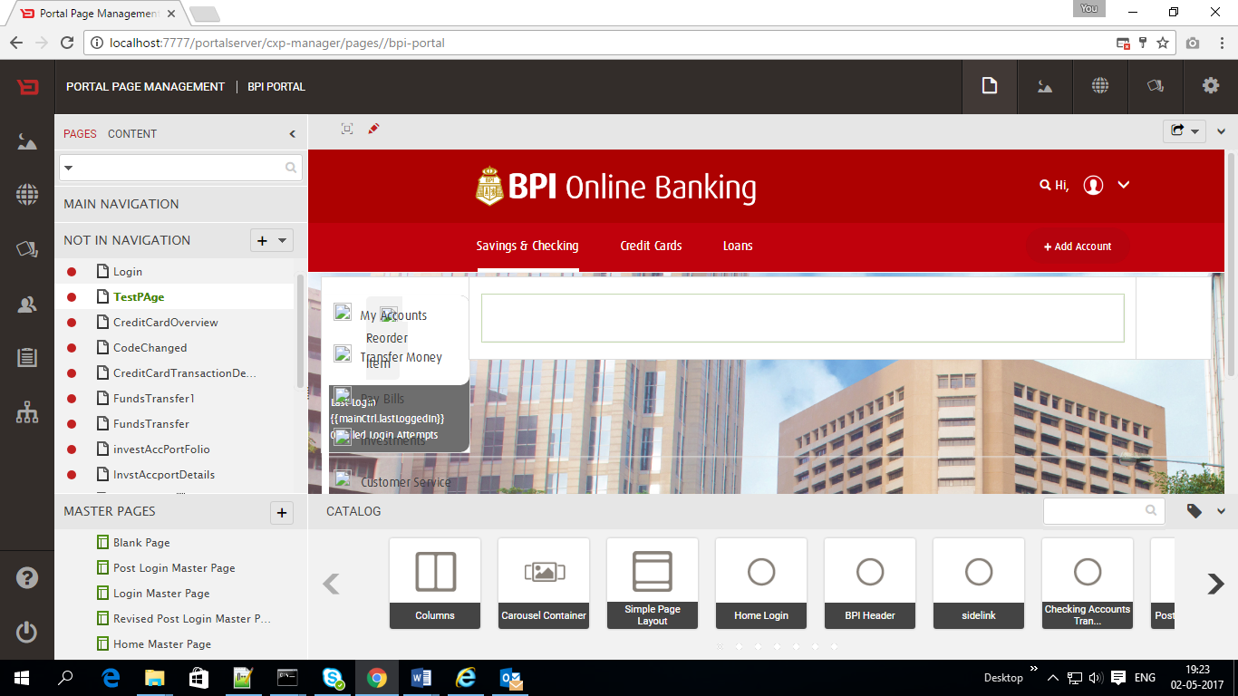

Steps for Export the Portal

**Step-1:** Go to CXP Manager and click on the Portal Configuration

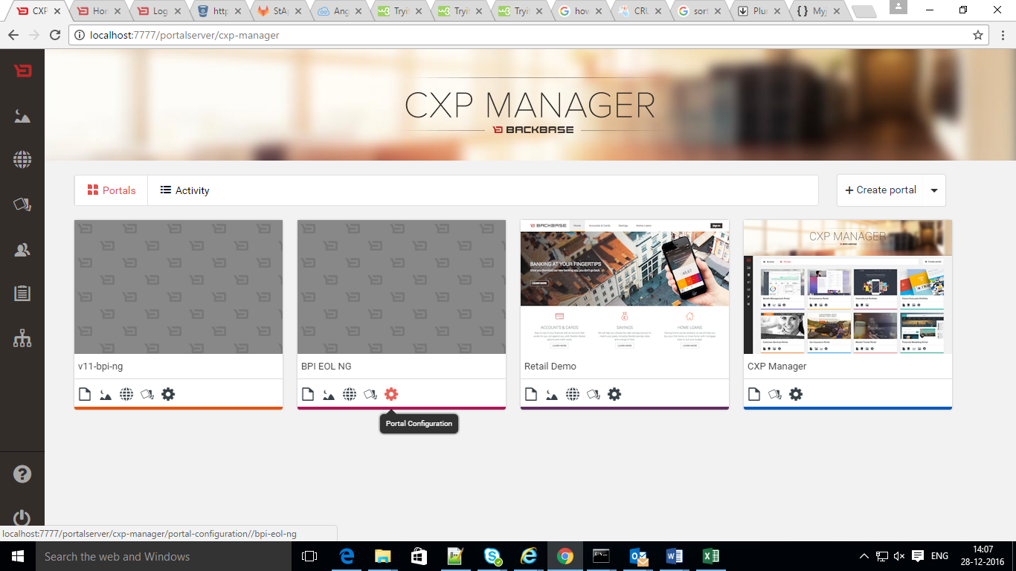

**Step-2**: Click on Export

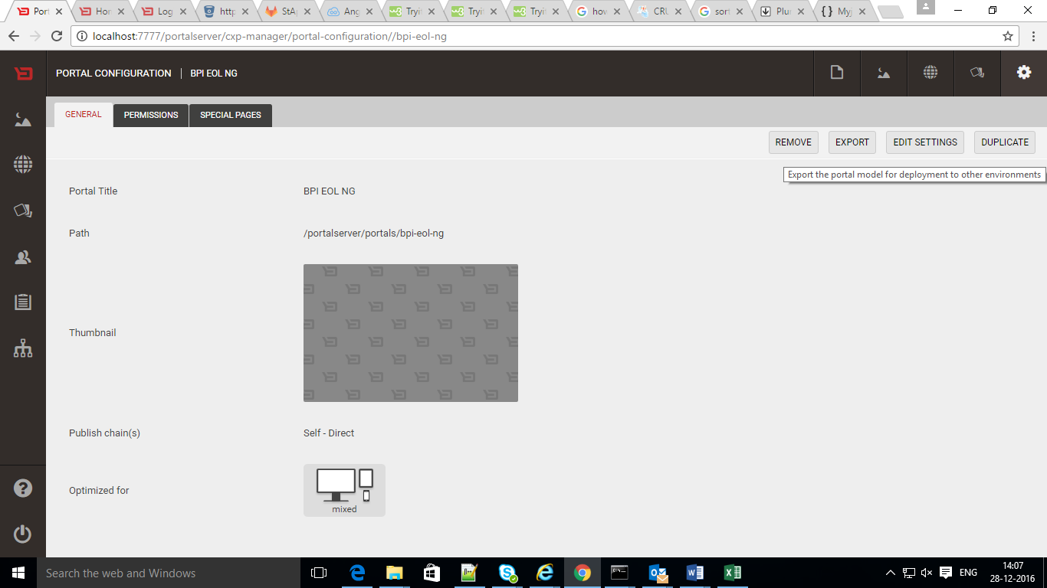

**Step-3:** Click on the Export

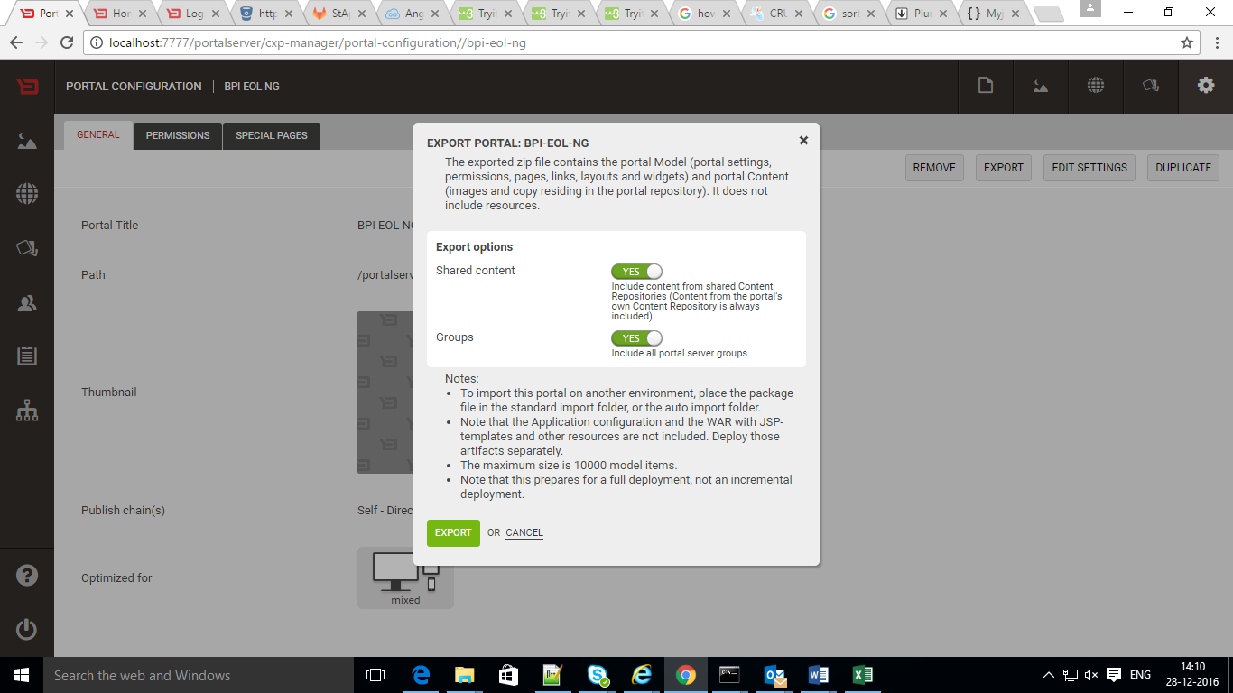

**Step-3:** Click on Download

